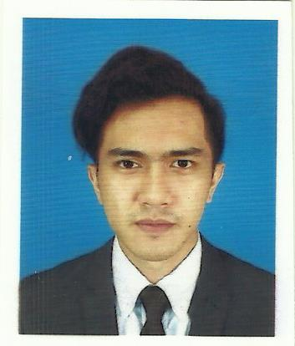**RESUME**

Name : Muhamed Izamir Bin Jamaludin

Date of birth : 20 August 1996

I/C Number : 960820-10-5245

Address : No 19 Jalan Warisan Permai , 2/2 Kota Warisan 43900 ,Sepang ,Selangor.

Phone Number : 011-21859971

E-mail : izamir.jamaludin@yahoo.com

EXTRA CURRICULAR ACTIVITIES

* Black belt in taekwondo academy
* Committee Member on School Youth Cadet Corps

.

EDUCATIONAL BACKGROUND

2014 - CURRENT

* Diploma In Technology Management

2009 - 2013

* Sijil Pelajaran Malaysia (SPM) 2A,2B,1C,2D,2E

SUBJECT TAKEN RELATED

* Financial Accounting I
* Financial Accounting II
* Introduction To Finance
* Management Information System
* Manufacturing Process
* Technical Drawing
* Operation Management

COMPUTER LITERACY

|  |  |
| --- | --- |
|  | Level |
| Microsoft Office | Good |
| Microsoft Excel | Good |
| Microsoft Power-Point | Good |
| AutoCAD | Good |

LANGUAGE SKILLS

|  |  |  |
| --- | --- | --- |
|  | Spoken | Written |
| Bahasa Malaysia | Excellent | Excellent |
| Bahasa Inggeris | Fluent | Fluent |

REFERENCE

1) Name : Madam Nurul Atiqah binti Maiden

Position : Head of Programme UTM

Company : Unifield International College

Contact Number : 017-624 2092

2) Name : Madam Norzaina Binti Abdul Rahman

Position : Assistant Head of Programme UTM

Contact Number : 019-2579484

2) Name : Madam Siti Asnita Binti Md Zin

Relation : Lecturer

Contact Number : 012-9057458

Email : asnita@uic.edu.my